Perception Armored

Team Members: Anthony, Calvin, Evan, Ro

Daily Scrum S1c

**Requirements ~**

* **Accomplished tasks for today:**
  + Talked about our 8 chosen Data Science applications
    - Anthony
      * <https://github.com/NU-DataCHI-4-Horsemen/Project1>
        + I would like to extrapolate something from my last project I made at NU Data Science Bootcamp. Back in 2019 5G infrastructure was fairly new and standing that up was a competitive market. We took that data from each carrier and did lots of cool stuff with it. I was thinking of doing something similar with EV charging stations just replacing the data sets with the same code used for this project. Below are 2 back up plans if my side project fails.
      * <https://github.com/perceptionarmored/fbigtech/blob/main/homework/sprint1/12-Web-Scraping-and-Document-Databases/2/Activities/03-Ins_Craigslist/Solved/Ins_Craigslist.ipynb>
      * <https://github.com/perceptionarmored/fbigtech/blob/main/homework/sprint1/10-Advanced-Data-Storage-and-Retrieval/2/Activities/02-Stu_SharkSearch/Solved/Stu_SharkSearch.ipynb>
    - Evan
      * <https://github.com/perceptionarmored/fbigtech/tree/main/homework/sprint1/04-Pandas/1/Activities/02-Stu_NetflixRemix>
      * <https://github.com/perceptionarmored/fbigtech/tree/main/homework/sprint1/04-Pandas/2/Activities/07-Par_Pokemon>
    - Ro
      * [GitHub - luka1199/geo-heatmap: Generate an interactive geo heatmap from your Google location data](https://github.com/luka1199/geo-heatmap)
      * [GitHub - PaulC91/crime-watch: Interface to access and map UK Police Data](https://github.com/PaulC91/crime-watch)
    - Calvin
      * <https://github.com/perceptionarmored/fbigtech/blob/main/homework/sprint1/06-Python-APIs/3/Activities/04-Ins_NearestRestr/Solved/NearestRestr.ipynb>
      * <https://github.com/perceptionarmored/fbigtech/blob/main/homework/sprint1/06-Python-APIs/2/Activities/07-Stu_Weather_Stats/Solved/weather_stats.ipynb>
  + Trello
    - Tom introduced us to Jira then told us about Trello if we wanted something with an easier learning curve
    - We all joined in on Trello and are ready to tackle a better system of assigning tasks and communications of tasking using Trello



* **Plan for tomorrow:**
  + Received RPi’s (SVR) with Tom’s instructions
    - 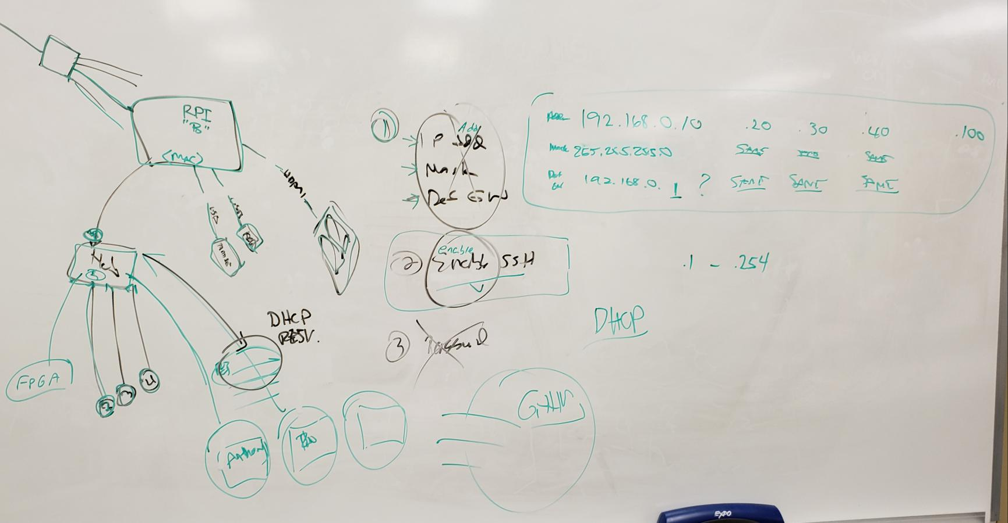
  + Helped Calvin prep for Sprint 2
    - Did a proper “Turn over” as we call it in the Navy
    - I showed him how I ran everything and what I could have done better (used Trello instead of hover over S1a assignment)
    - Made sure we were still on the same page with my over all vision of how sprint 2 would look based on our previous discussions from meetings
* **Road blocks?:**
  + Balsamic and time
    - Not blaming anyone but myself, but it seems the more help I get the bigger the vision
      * Now have Rob and Engineering department involved to help with FPGA boards I ordered and am in possession of
        + Little did I know, I ordered one of the more complicated board they don’t teach at Dunwoody, but one of the instructors has familiarity with FPGA computational programming and can at least help me get the thing up and running
        + They also gave me fun hand outs and Labs to learn from. I had no idea FPGA board development was taught here!
    - Balsamic will definitely need some time to wrap my head around. I’ve always been a fan of dry erase boards for quick and easy thought sketch and passing of ideas during the brainstorming process
      * I would love to get the input from the other instructors first and get their professional advice on how to connect everything. But I owe the team a Sprint 2 balsamic at least for the planning meeting